SQL Injection
- Attacker logs into the system using his own account
- Attacker has access to a request that finds a user for example
  - http://website/api/users/{Name}
- Attacker is able to inject SQL Code into this request like
  - http://website/api/users/{‘Bob or 1=1’}
  - 1=1 evaluates to true to all users will be returned
  - Of course there are many types of SQL Injections and also this depends on what the functionality does and what the website shows here we are assuming everything works in attacker’s favor but the main idea is embedding SQL Code inside a request
- Types of SQL Injection
  - In Band SQLi (Union Based) 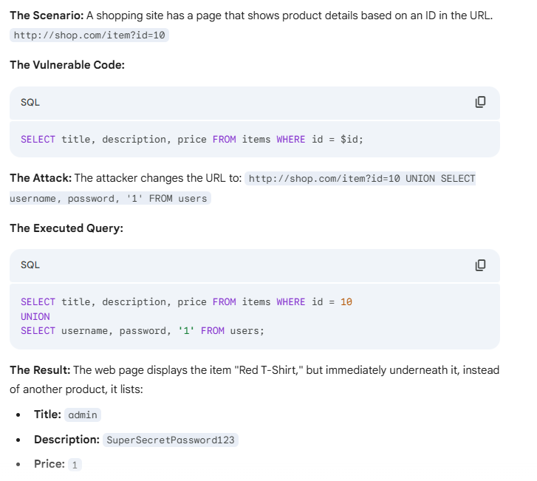
  - Inferential (Blind) SQLi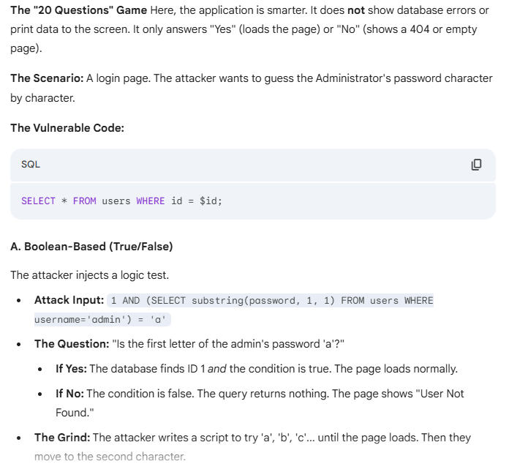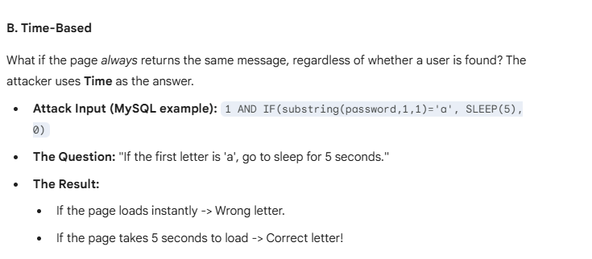
  - Out-Of-Band SQLi